Batch: 4
Roll No.: 16010123012

Experiment / Assignment / Tutorial No.: 07

TITLE: To explore data using filters, joins, and calculations
Objective:

- Apply basic and advanced filters to slice and explore data
- Join multiple tables using relationships in Power BI
- Create calculated columns and DAX measures for custom analysis
- Combine filters, joins, and calculations to answer business questions
_______________________________________________________

Expected outcome of Experiment:
Students will be able to explore and analyze sales data in Power BI by applying filters to isolate specific data subsets, joining multiple tables to enrich the dataset, and creating DAX calculations to derive meaningful business metrics. By the end of the experiment, students will have built an interactive dashboard that demonstrates all three concepts working together

CO3 | Apply data visualization best practices

_______________________________________________________________
Books/ Journals/ Websites referred:
https://learn.microsoft.com/en-us/power-bi/
_____________________________________________________________________
Background Theory:
A filter is a condition applied to data that restricts what is displayed in a visual or report. Filtering does not delete data — it simply hides rows that do not match the specified criteria. When you remove the filter, all data becomes visible again. Filters are used to focus analysis on a specific subset of data, such as a particular region, time period, or product category. In everyday business scenarios, filters answer questions like: 'Show me only sales from the West region' or 'Display only orders placed in 2021.' Filters are the most basic but most frequently used tool in any BI platform.
A join is an operation that combines rows from two or more tables based on a related column. In relational databases, tables are deliberately kept separate and lean — each table stores one type of information. For example, an Orders table stores transaction data, while a Customers table stores customer details. A join links these two tables through a shared key (such as Customer ID) so that combined analysis is possible. Without joins, analysts would be forced to work with a single massive flat table containing all columns, which leads to data redundancy, inconsistency, and poor performance. Joins are the backbone of relational data modeling.
DAX stands for Data Analysis Expressions. It is the formula language used in Power BI (as well as Excel Power Pivot and Azure Analysis Services) to define custom calculations. DAX is designed specifically for working with relational data models and is highly optimized for aggregation, filtering, and time intelligence operations.DAX syntax is similar to Excel formulas in style but operates at the table and column level rather than the cell level. A single DAX measure can aggregate millions of rows in milliseconds and dynamically recalculate based on the current filter context.
Note: Perform below task in power Bi on sample supermarket dataset.
Task 1: Apply a Basic Visual-Level Filter
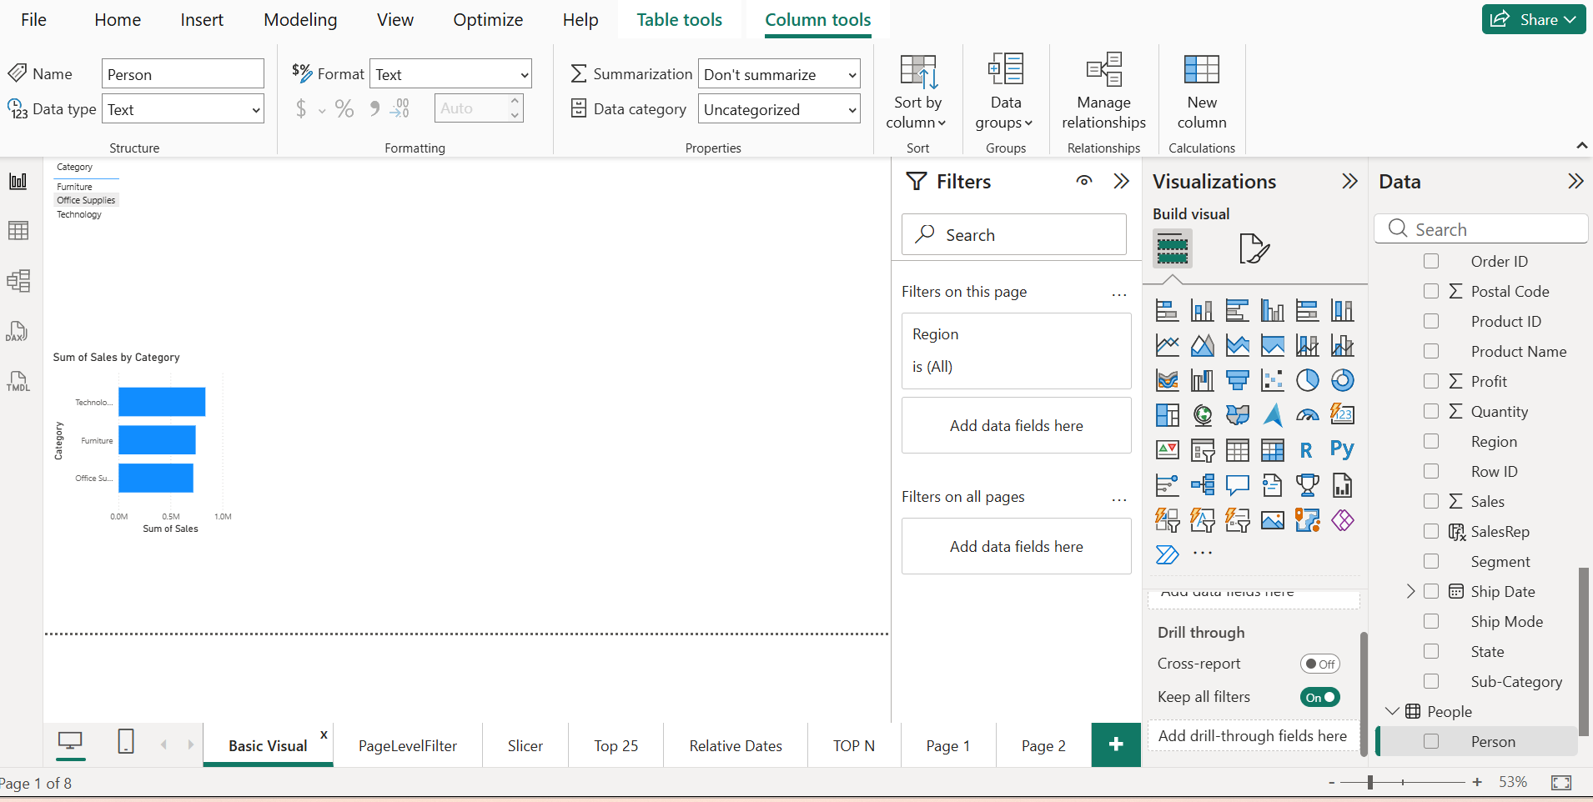
Steps:
- Create a Bar Chart showing Sum of Sales by Category.
- In the Filters pane, expand 'Filters on this visual'.
- Drag the Region field into the filter area.
- Select only 'West' from the filter values.
- Observe how only West region data now appears in the chart.

Task 2: Apply a Page-Level Filter
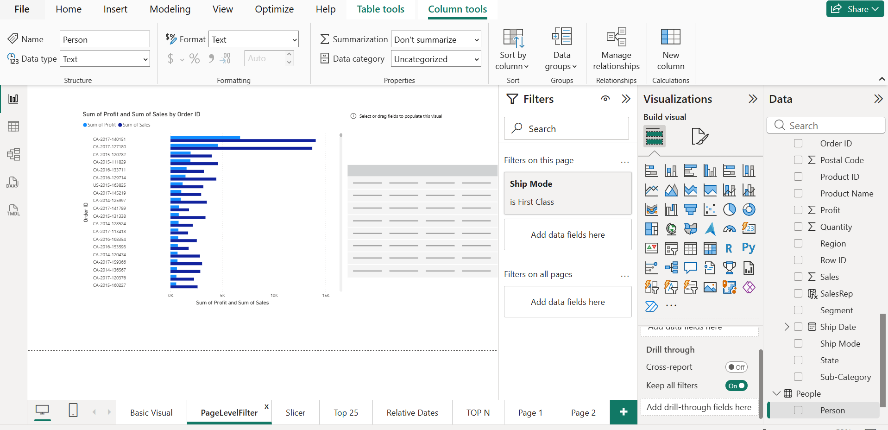
Steps:
- Add a second visual to the same page — a table showing Order ID, Sales, and Profit.
- In the Filters pane, go to 'Filters on this page'.
- Drag Ship Mode into this section.
- Select 'First Class' only.
- Observe that BOTH visuals on the page now show First Class data only.
Task 3: Create an Interactive Slicer
Steps:
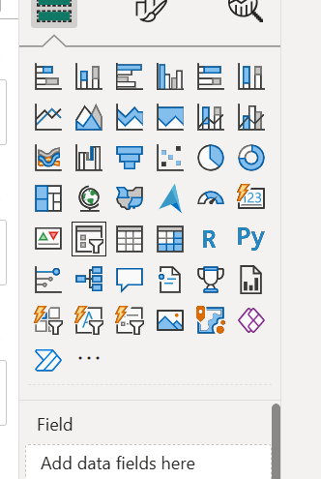

- Click on an empty area of the canvas.
- In the Visualizations pane, select the Slicer visual.
- Drag the Category field into the slicer.
- Create a second slicer using the Year from Order Date (use the date hierarchy).
- Test the slicers by selecting different categories and years.
Task 4: Use Top N Filter
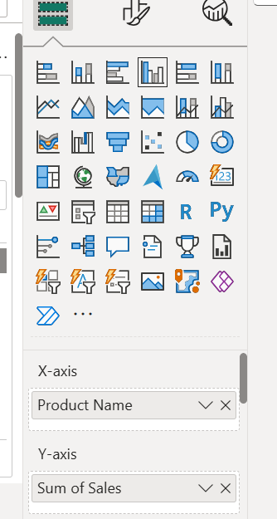

Steps:
- Create a Bar Chart showing Sum of Sales by Product Name.
X axis: product name and Y axis : Sum Sales
- In Filters on this visual, drag Product Name into the filter area.
In filter add product name
- Change filter type from 'Basic filtering' to 'Top N'.
- Set Show items = Top 10, By value = Sum of Sales.
- Click Apply filter.

Task 5: Apply a Date Range Filter
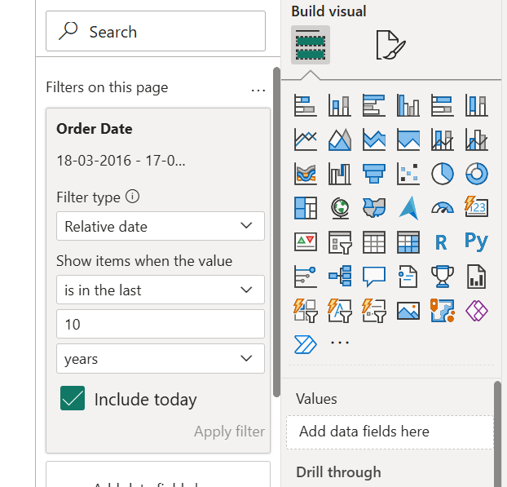
Steps:
- Create a Line Chart showing Sum of Sales over Order Date.
- In Filters on this visual, drag Order Date into the filter area.
- Change filter type to 'Relative date'.
- Set it to show 'Last 2 Years'.
- Alternatively, use 'Between' to set a custom date range (e.g., Jan 2020 to Dec 2021).
Task 6: View and Understand Existing Relationships
Steps:
- Click the Model view icon on the left sidebar (looks like three connected shapes).
- Observe the relationship lines between Orders, Returns, and People tables.
- Double-click on the relationship line between Orders and Returns.
- Note the joining key (Order ID), cardinality, and cross-filter direction.
- Close the dialog. Sketch or note down what you observe.
Task 7: Create a New Relationship Manually
Steps:
- In Model view, check if Orders and People tables are connected.
- If not, drag the Region field from the People table to the Region field in the Orders table.
- In the relationship dialog, confirm Cardinality = Many to One, Cross-filter = Single.
- Click OK to create the relationship.
- Go back to Report view and create a table showing Region, Sales Rep (from People), and Sum of Sales.
Task 8: Identify Returned Orders Using a Join
Steps:
- Go to Home > Transform Data to open Power Query Editor.
- Select the Orders query in the left panel.
- Go to Home > Merge Queries.
- Select Returns as the second table, match on Order ID, and choose Left Outer join.
- Expand the merged column and bring in the 'Returned' column.
- Close and Apply. Back in Power BI, create a table showing Order ID, Sales, and Returned status.
Use maximize view of power bi query editor
Added new columns in the new table which gets automatically added in to power bi
Task 9: Calculate Total Sales for Returned vs Non-Returned Orders
Steps:
- Using the Returned column you added in Task 8, create a Bar Chart.
- Set the Y axis to Returned (Yes / blank) and X axis to Sum of Sales.
- Add a data label to show the actual sales values.
- Format the chart with appropriate title: 'Sales: Returned vs Non-Returned'.
Task 10: Use RELATED Function Across Tables
Steps:
- In the Report view, go to the Orders table in the Data pane.
- Right-click > New Column.
- Enter the formula: Sales Rep = RELATED(People[Person])
- This pulls the Sales Rep name from the People table into each Order row.
- Create a table visual showing Order ID, Customer Name, Sales, and Sales Rep.

Implementation Details:
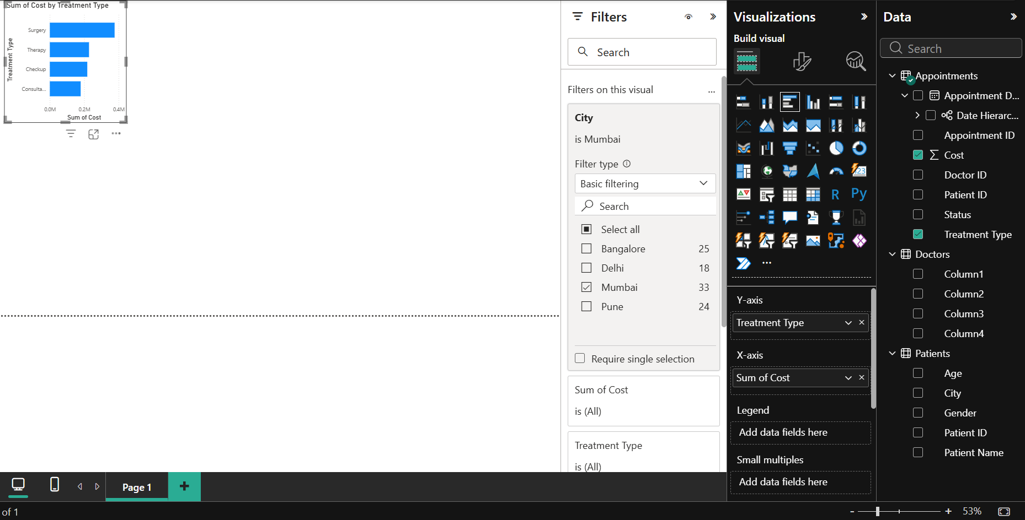Task 1
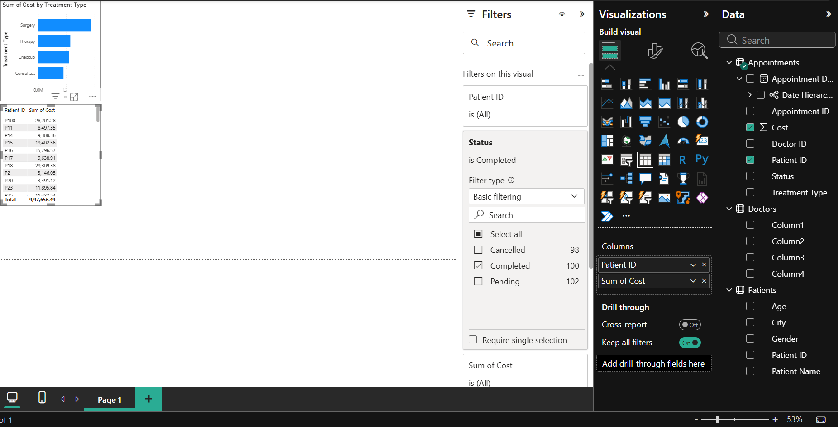
Task 2

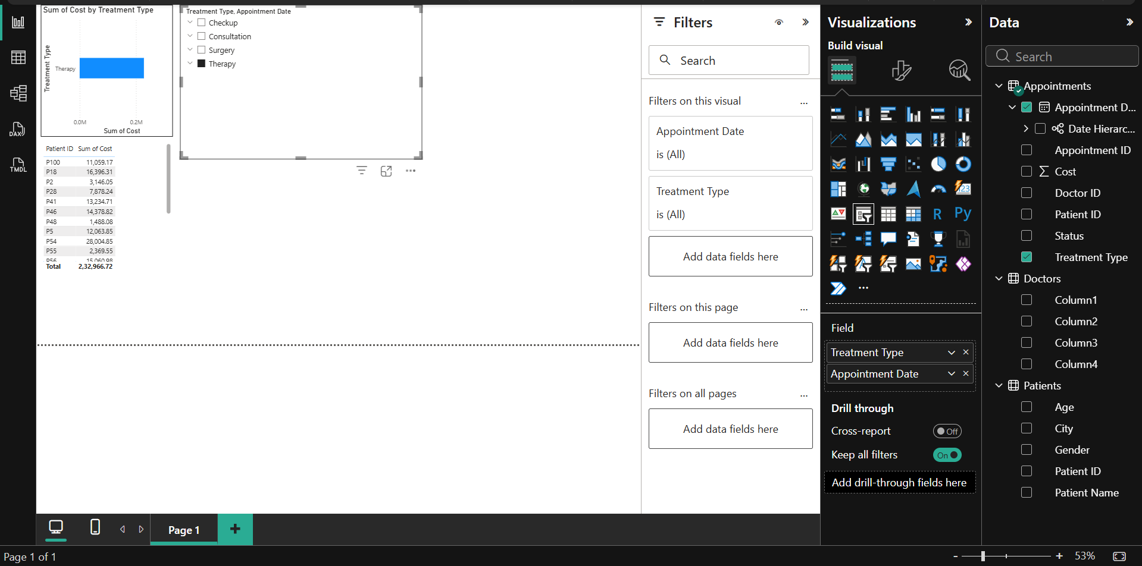Task 3
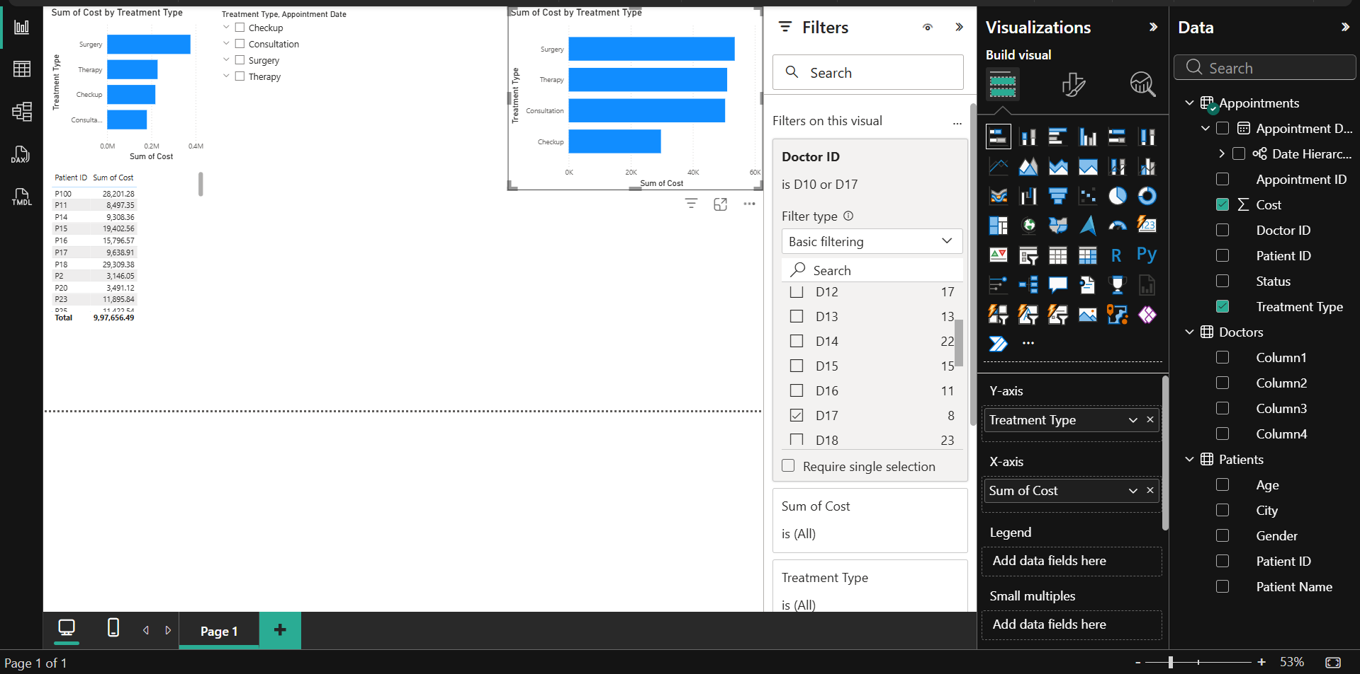
Task 4

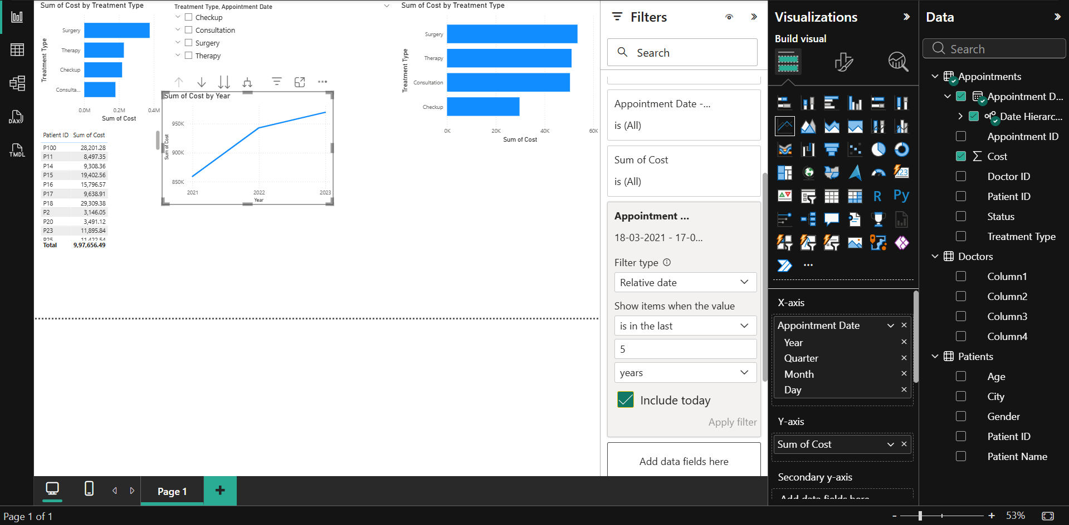Task 5
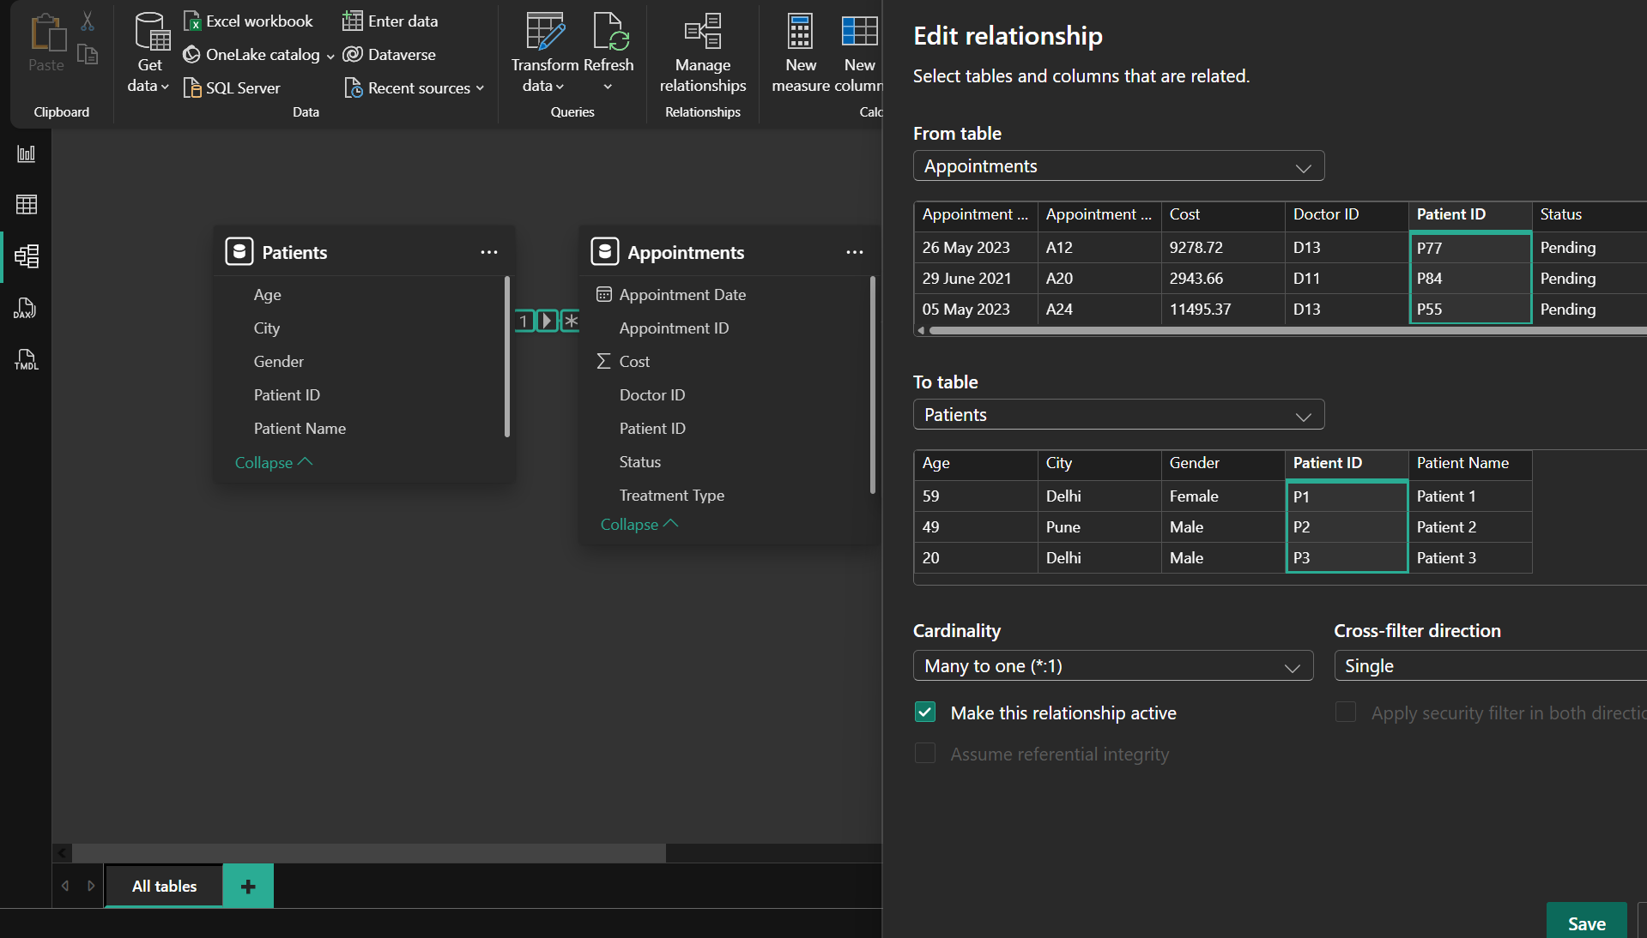
Task 6
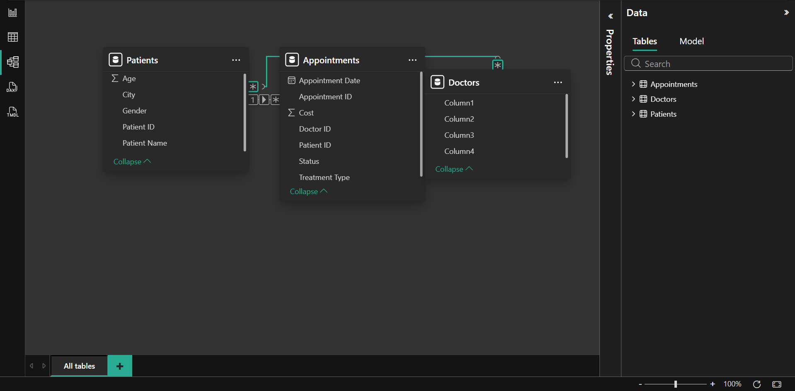Task 7
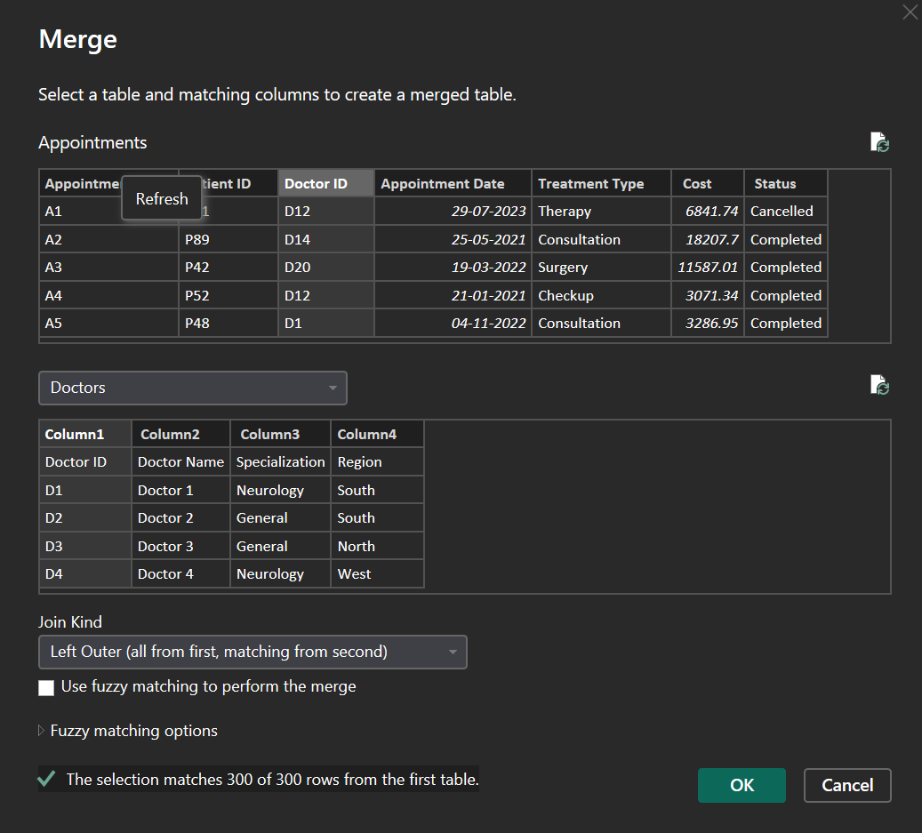
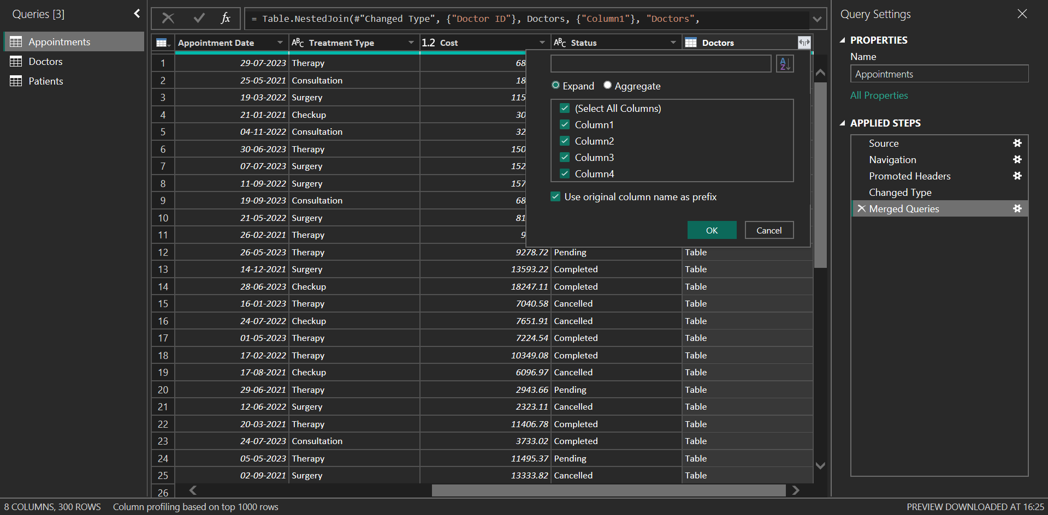
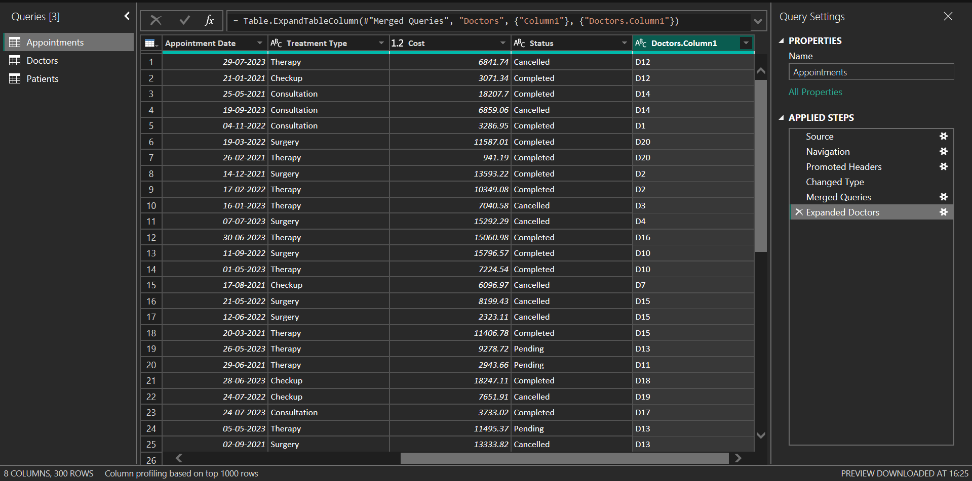
Task 8
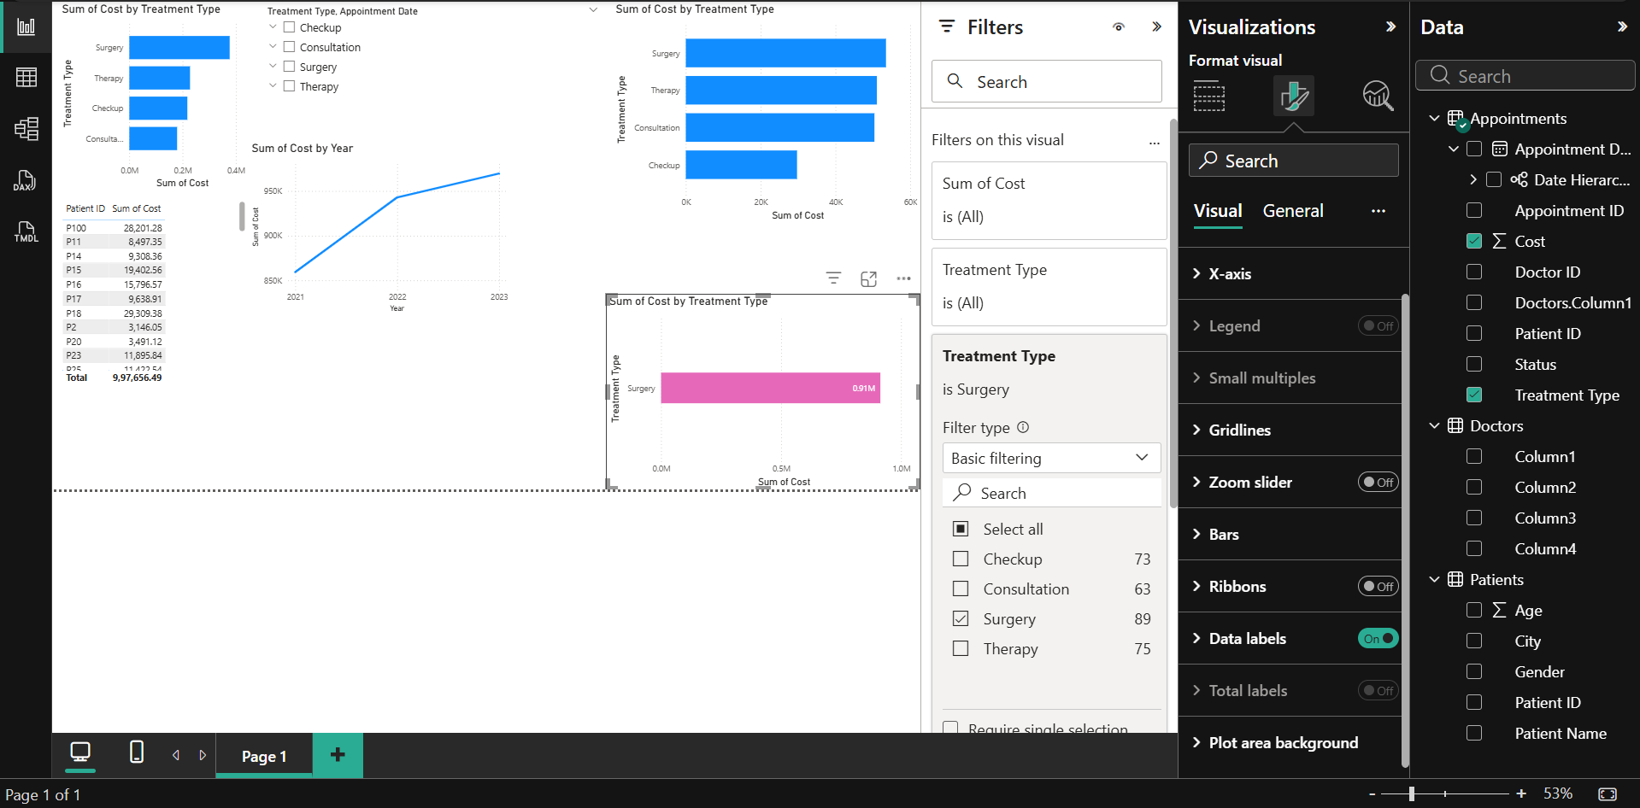
Task 9
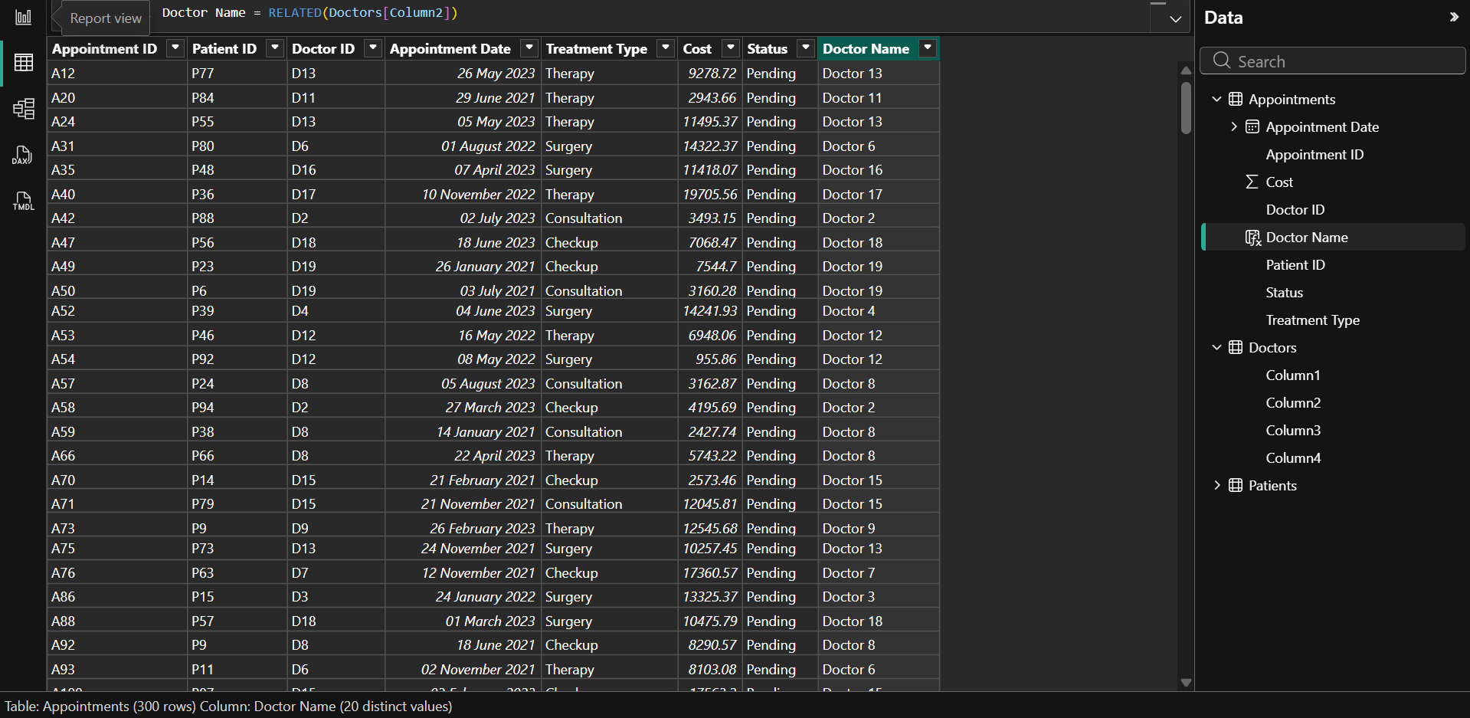Task 10
Conclusion:
This experiment demonstrated how data can be effectively explored and analyzed in Power BI using filters, relationships, and DAX calculations. Various filtering techniques such as visual-level filters, page-level filters, slicers, Top N filters, and date filters were applied to isolate specific subsets of data and analyze trends. Relationships between tables were examined and created to enable meaningful connections across datasets, while joins were used to combine data for deeper insights. Additionally, calculated columns and DAX functions such as RELATED were used to derive new information and enhance analysis.

Post Laboratory Questions
- What is the difference between a visual-level filter and a slicer in Power BI?
A visual-level filter is applied to a single visual and affects only that specific chart or table, allowing focused analysis within that visual. In contrast, a slicer is an interactive filtering tool placed on the report canvas that allows users to filter multiple visuals simultaneously. Visual-level filters are static and configured in the filter pane, whereas slicers provide dynamic and user-controlled filtering.
- What is a relationship in Power BI and why is it needed?
A relationship in Power BI is a connection established between two tables using a common column such as Order ID or Region. It allows data from multiple tables to be combined logically without physically merging them. Relationships are needed to perform accurate analysis across datasets, reduce data redundancy, and enable efficient data modeling.
- What is the difference between a Calculated Column and a Measure in DAX?
A calculated column is computed for each row in a table and stored in the data model, meaning its values remain fixed unless the data is refreshed. A measure, on the other hand, is calculated dynamically based on the current filter context and is not stored in the table. Measures are typically used for aggregations such as totals or averages, while calculated columns are used for row-level computations.

